What is linear regression, and how does it work?

Linear regression is a statistical method used to model the relationship between a dependent variable and one or more independent variables. It is called "linear" because the model assumes a linear relationship between the dependent and independent variables.

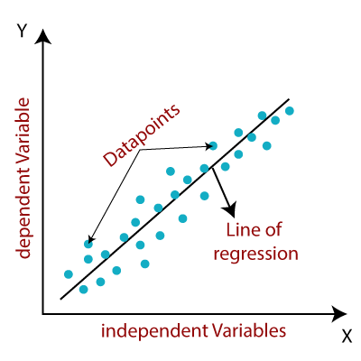

Linear regression can be classified into two types: Simple Linear Regression and Multiple Linear Regression. Simple Linear Regression involves using one independent variable to model the relationship between that variable and a dependent variable.On the other hand, Multiple Linear Regression involves using more than one independent variable to model the relationship with the dependent variable.
In linear regression, a line of best fit is plotted on a scatter plot of the data points, and the equation of this line is used to make predictions about the dependent variable based on the values of the independent variable(s). The line is determined by finding the values of the slope and intercept that minimize the sum of the squared differences between the observed values and the values predicted by the line.
Linear regression can be used for both continuous and categorical dependent variables and can handle multiple independent variables. It is commonly used in fields such as economics and finance to model the relationship between variables and make predictions or forecasts.

What are the assumptions of a linear regression model?
The assumptions of a linear regression model are:
- The relationship between the independent and dependent variables is linear.
- The residuals, or errors, are normally distributed with a mean of zero and a constant variance.
- The independent variables are not correlated with each other (i.e. they are not collinear).
- The residuals are independent of each other (i.e. they are not autocorrelated).
- The model includes all the relevant independent variables needed to accurately predict the dependent variable.

How do you determine the best-fit line for a linear regression model?
To determine the best-fit line for a linear regression model, the following steps can be taken:
- Collect a sample of data points that represent the relationship between the dependent and independent variables.
- Plot the data points on a scatter plot to visualize the relationship between the variables.
- Calculate the linear regression equation using the least squares method to find the line that minimizes the distance between the data points and the line.
- Use the linear regression equation to predict the value of the dependent variable for a given value of the independent variable.
- Evaluate the accuracy of the model by calculating the coefficient of determination (R2) and the root mean squared error (RMSE).
- Adjust the model, if necessary, by adding or removing variables or transforming the data to improve the fit of the model.
- Use the adjusted model to make predictions and continue to evaluate its performance.

What is the difference between simple and multiple linear regression?
Simple linear regression models the relationship between one independent variable and one dependent variable, while multiple linear regression models the relationship between multiple independent variables and one dependent variable. The goal of both methods is to find a linear model that best fits the data and can be used to make predictions about the dependent variable based on the independent variables.

What is the difference between linear regression and logistic regression?
Linear regression is a statistical method used for predicting a numerical outcome, such as the price of a house or the likelihood of a person developing a disease.
Logistic regression, on the other hand, is used for predicting a binary outcome, such as whether a person will pass or fail a test, or whether a customer will churn or not.
The main difference between these two types of regression lies in the output they predict. Linear regression is used to predict a continuous output, while logistic regression is used to predict a binary output. This means that the equations and the processes used to train and evaluate the models are different for each type of regression.

What are the common types of errors in linear regression analysis?
Several types of errors can occur in linear regression analysis. Some of the most common include:
- Overestimating or underestimating the relationship between the variables: This can happen if the model is too complex or if important variables are left out of the model.
- Incorrect functional form: The chosen functional form (e.g. linear, log-linear, etc.) may not accurately represent the relationship between the variables.
- Non-linearity of the residuals: The residuals (the difference between the observed values and the predicted values) should be randomly distributed around zero if the model is correct. If the residuals exhibit non-linear patterns, it may indicate that the chosen model is not the best fit for the data.
- Multicollinearity: This occurs when two or more predictor variables in a model are highly correlated, which can cause unstable coefficient estimates and make it difficult to interpret the results.
- Outliers: Outliers, or extreme values in the data, can have a significant impact on the fitted values and coefficients in a linear regression model. It is important to identify and address any potential outliers in the data before fitting a model.
Overall, the key to avoiding errors in linear regression analysis is to carefully examine the data and ensure that the chosen model is the best fit for the relationship between the variables.

What is the difference between a dependent and independent variable in linear regression?
In linear regression, the dependent variable is the variable that is being predicted or explained by the model. This is the variable that is dependent on the independent variables. The independent variable, on the other hand, is the variable that is used to predict or explain the dependent variable. It is independent of the dependent variable and is not affected by its value.
Aspect | Dependent Variable | Independent Variable
Definition | The variable that is being predicted or explained | The variable used to make the prediction or explanation
Also known as | Response variable, outcome variable, predicted variable | Predictor variable, explanatory variable, input variable
Role in the regression equation | Y-axis variable | X-axis variable
Notation | Usually represented as "Y" | Usually represented as "X"
Assumption | The dependent variable is assumed to be affected by the independent variable(s) | The independent variable(s) are assumed to have a linear relationship with the dependent variable
Goal | To understand how changes in the independent variable(s) affect the dependent variable | To use the independent variable(s) to predict or explain the values of the dependent variable
Example | In a study on the effect of hours of study on exam scores, exam score would be the dependent variable | In the same study, hours of study would be the independent variable

How do you measure the strength of a linear relationship between two variables?
One way to measure the strength of a linear relationship between two variables is by calculating the correlation coefficient, which is a measure of the strength and direction of the linear relationship between the two variables. The correlation coefficient ranges from -1 to 1, with -1 indicating a perfect negative linear relationship, 0 indicating no linear relationship, and 1 indicating a perfect positive linear relationship. A higher absolute value of the correlation coefficient indicates a stronger linear relationship between the two variables.

What is the difference between a population regression line and a sample regression line?

A population regression line is a mathematical model that describes the relationship between a dependent variable and one or more independent variables in a population. It is based on the entire population and is used to make predictions about the population as a whole.
A sample regression line, on the other hand, is a mathematical model that describes the relationship between a dependent variable and one or more independent variables in a sample. It is based on a subset of the population and is used to make predictions about the sample and to estimate the population regression line.

What is a residual in linear regression and how is it used in model evaluation?
In linear regression, a residual is the difference between the predicted value of the dependent variable (based on the model) and the actual observed value. It is used to evaluate the performance of the model by measuring how well the model fits the data. If the residuals are small and evenly distributed around the mean, it indicates that the model is a good fit for the data. However, if the residuals are large and not evenly distributed, it indicates that the model may not be a good fit for the data and may need to be improved or refined.

What is the difference between linear regression and non-linear regression?
Linear regression is a statistical method that uses a linear equation to model the relationship between a dependent variable and one or more independent variables. The linear equation is of the form y = mx + b, where y is the dependent variable, x is the independent variable, m is the slope of the line, and b is the y-intercept. In linear regression, the relationship between the variables is assumed to be linear, meaning that the dependent variable changes at a constant rate concerning the independent variable.
Non-linear regression, on the other hand, is a statistical method that uses a non-linear equation to model the relationship between a dependent variable and one or more independent variables. The non-linear equation can be of many different forms, including polynomial equations, exponential equations, and logarithmic equations. In non-linear regression, the relationship between the variables is not assumed to be linear, meaning that the dependent variable can change at different rates with respect to the independent variable.

What are the common techniques used to improve the accuracy of a linear regression model?
- Feature selection: selecting the most relevant features for the model to improve its predictive power.
- Feature scaling: scaling the features to a similar range to prevent bias towards certain features.
- Regularization: adding a penalty term to the model to prevent overfitting and improve generalization.
- Cross-validation: dividing the data into multiple partitions and using a different partition for validation in each iteration to avoid overfitting.
- Ensemble methods: combining multiple models to improve the overall accuracy and reduce variance.
What is the difference between a parametric and non-parametric regression model?
A parametric regression model is a model that assumes a specific functional form for the relationship between the dependent and independent variables and estimates the model parameters based on the data. This means that the model has a fixed number of parameters, and the model structure is predetermined.
On the other hand, a non-parametric regression model does not assume any specific functional form for the relationship between the dependent and independent variables and instead estimates the relationship using a flexible, data-driven approach. This means that the model does not have a fixed number of parameters, and the model structure is not predetermined. Instead, the model is determined based on the data itself.

How do you determine the significance of a predictor variable in a linear regression model?
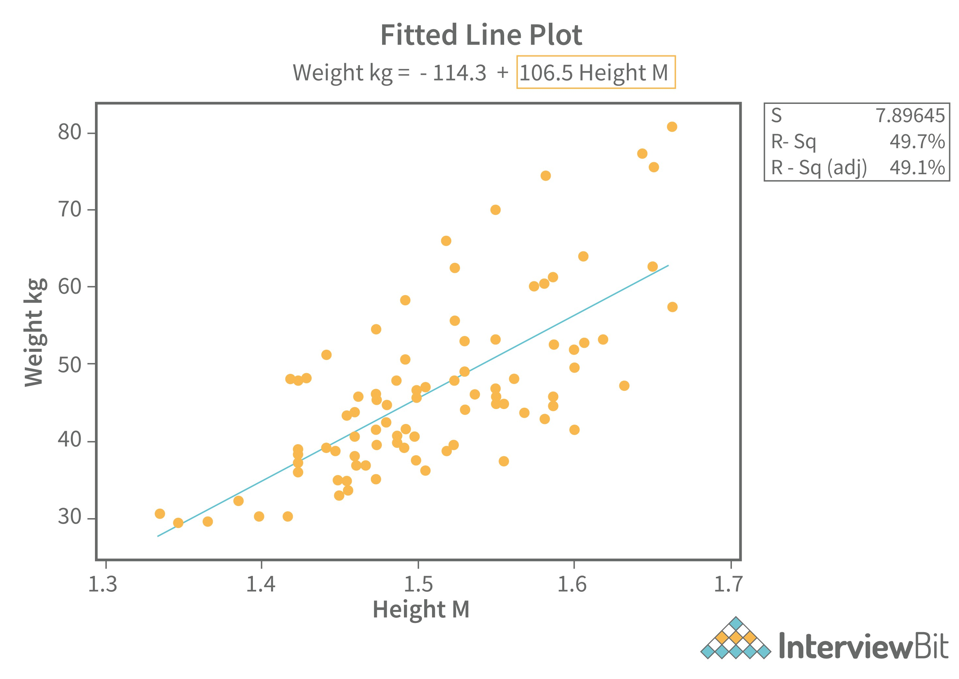
One way to determine the significance of a predictor variable in a linear regression model is to evaluate its p-value. If the p-value is below a certain threshold, typically 0.05, it indicates that the predictor variable has a statistically significant relationship with the response variable.

Another way to determine the significance of a predictor variable is to evaluate its coefficient in the regression equation. A large magnitude of the coefficient indicates a strong relationship between the predictor and response variables. Additionally, comparing the coefficient of the predictor variable with the coefficients of other predictor variables in the model can provide insight into its relative importance in predicting the response variable.

What is the role of a dummy variable in linear regression analysis?
A dummy variable in linear regression analysis is used as a substitute for an unobserved or non-measured categorical variable. It is used to represent the presence or absence of a specific category in the data set.
For example, in a study of the relationship between income and education level, a dummy variable could be used to represent the presence or absence of a college degree. This allows the model to differentiate between individuals with and without a college degree, and account for any potential effects of this variable on the outcome of the analysis.

What is heteroscedasticity?
Heteroscedasticity is a statistical term that refers to the unequal variance of the error terms (or residuals) in a regression model. In a regression model, the residuals represent the difference between the observed values and the predicted values of the dependent variable. When heteroscedasticity occurs:
The variance of the error terms is not constant across the range of the independent variables.
Error terms tend to be larger for some values of the independent variables than for others.
This can result in biased and inconsistent estimates of the regression coefficients and standard errors, which can affect the accuracy of the statistical inferences and predictions made from the model.
Heteroscedasticity can be caused by a number of factors, including:
Outliers
Omitted variables
Measurement errors
Nonlinear relationships between the variables
It is important to detect and correct for heteroscedasticity in a regression model to ensure the validity and reliability of the statistical results. This can be done by:
Using methods such as weighted least squares, robust regression, or transforming the variables.
Graphical methods, such as residual plots, can also be used to detect heteroscedasticity.

What is the difference between a categorical and continuous variable in linear regression?
A categorical variable is a variable that can take on one of a limited number of values, such as "male" or "female". A continuous variable is a variable that can take on any value within a certain range, such as "height" or "weight".
In linear regression, a categorical variable is typically represented by a dummy variable, which is a binary variable that indicates the presence or absence of a particular category. Continuous variables, on the other hand, are typically represented by their actual values.

How do you evaluate the goodness of fit of a linear regression model?
There are a few different ways to evaluate the goodness of fit of a linear regression model. One of the most common is to use the coefficient of determination, also known as the R-squared value. This is a measure of how well the regression line fits the data, with a value of 1 indicating a perfect fit and a value of 0 indicating that the model does not explain any of the variances in the data.
Another common way to evaluate the goodness of fit is to use the root mean squared error (RMSE), which is a measure of the difference between the predicted values and the actual values in the data. A smaller RMSE indicates a better fit.

What is the role of a regression coefficient in linear regression analysis?
A regression coefficient in linear regression analysis represents the strength and direction of the relationship between a predictor variable and the response variable. It indicates the average change in the response variable for every unit change in the predictor variable while controlling for the effects of other predictor variables in the model. The sign of the coefficient indicates the direction of the relationship (positive or negative), and the magnitude of the coefficient indicates the strength of the relationship.

What is a prediction interval in linear regression and how is it used?
A prediction interval in linear regression is a range of values that is likely to contain the value of a new observation given a set of predictor variables. It is used to provide a more accurate estimate of the uncertainty of a predicted value, as it takes into account both the uncertainty of the regression model and the error associated with a new observation. This can be useful for making more informed predictions and decision-making based on those predictions.

How to find RMSE and MSE?
RMSE (Root Mean Squared Error) and MSE (Mean Squared Error) are both measures of the difference between predicted and actual values in a regression model.
To calculate MSE:
1.Take the difference between each predicted value and its corresponding actual value.
2.Square each of these differences.
3.Add up all of the squared differences.
4.Divide the sum by the total number of observations in the data set.
The formula for MSE is:
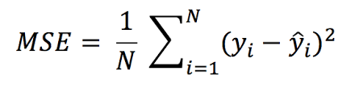
where n is the total number of observations, Yi is the actual value of the dependent variable, and Ŷi is the predicted value of the dependent variable.
To calculate RMSE, take the square root of the MSE value:
RMSE and MSE provide a measure of how far the predicted values are from the actual values in a regression model. A smaller RMSE or MSE indicates that the model is better at predicting the dependent variable.

How do you test for autocorrelation in a linear regression model?
A linear regression model with a positive correlation indicates that as the value of one variable increases, the value of the other variable also increases. In contrast, a linear regression model with a negative correlation indicates that as the value of one variable increases, the value of the other variable decreases.

What are the common challenges faced when building a linear regression model?
There are several common challenges that can arise when building a linear regression model. Some of these include:
1.Poor quality data: Linear regression relies on having high-quality data to make accurate predictions. If the data is noisy, missing, or has outliers, the model may not be able to make accurate predictions.
2.Nonlinear relationships: Linear regression is based on the assumption that the relationship between the dependent and independent variables is linear. If the relationship is nonlinear, the model may not be able to accurately capture it.
3.Multicollinearity: Multicollinearity occurs when there are strong correlations between two or more independent variables in the dataset. This can cause the model to be less stable and make it difficult to interpret the results.
4.Overfitting: Overfitting occurs when a model is overly complex and is able to fit the noise in the data, rather than the underlying relationship. This can cause the model to perform well on the training data but poorly on new, unseen data.
5.Underfitting: Underfitting occurs when a model is too simple to capture the underlying relationship in the data. This can cause the model to perform poorly on both the training and test data.
Overall, building a successful linear regression model requires careful preprocessing of the data, selecting appropriate features, and choosing the right model complexity.

Can you explain the concept of collinearity and how it affects a linear regression model?
Collinearity refers to the relationship between two or more predictor variables in a linear regression model. It occurs when the predictor variables are highly correlated with each other, meaning that they are measuring the same underlying concept or phenomenon.
Collinearity can affect the results of a linear regression model in several ways. Firstly, it can make the coefficients of the predictor variables unstable and difficult to interpret. This is because collinearity can cause the coefficients to vary greatly depending on the specific data that is used in the model.
Secondly, collinearity can lead to problems with model selection. In particular, it can cause the model to overfit the data, meaning that it will perform well on the training data but not generalize well to new data. This can lead to a model that is not useful for making predictions or making decisions.
Thirdly, collinearity can also affect the statistical significance of the predictor variables. If the predictor variables are highly correlated with each other, it can be difficult to determine which variables are truly contributing to the model and which are just noise.

How do you choose the right variables for a linear regression model?
The variables chosen for a linear regression model should be carefully selected based on the following factors:
1.Relevance: The variables should be relevant to the problem at hand and should have a clear relationship with the dependent variable.
2.Correlation: The variables should be correlated with the dependent variable. This can be determined by calculating the correlation coefficient between the variables and the dependent variable.
3.Multicollinearity: The variables should not be highly correlated with each other, as this can lead to problems with the model's ability to accurately predict the dependent variable.
4.Interpretability: The variables should be easy to interpret and explain, as this will make the model more understandable and easier to use.
5.Data availability: The data for the chosen variables should be readily available and should be of good quality.
Once these factors have been considered, the most appropriate variables can be selected for the linear regression model.

What is the role of regularization techniques in preventing overfitting in linear regression?
Regularization techniques, such as L1 and L2 regularization, are used in linear regression to prevent overfitting by adding a penalty term to the cost function. This penalty term encourages the model to prioritize simplicity and reduces the complexity of the model, thereby limiting the amount of overfitting. Regularization techniques help to strike a balance between model complexity and model performance, allowing the model to generalize well to unseen data.

Can you explain the concept of overfitting in linear regression
Overfitting in linear regression occurs when a model is trained on a limited amount of data and becomes too complex, resulting in poor performance when making predictions on unseen data. This happens because the model has learned to fit the noise or random fluctuations in the training data, rather than the underlying patterns and trends. As a result, the model is not able to generalize well to new data and may produce inaccurate or unreliable predictions. Overfitting can be avoided by using regularization techniques, such as introducing penalty terms to the objective function or using cross-validation to assess the model's performance.

What are the limitations of linear regression?
1.Linear regression is limited to modelling linear relationships between dependent and independent variables. It cannot model non-linear relationships.
2.Linear regression assumes a linear relationship between the dependent and independent variables. If this assumption is violated, the model may not be accurate.
3.Linear regression assumes that the residuals are normally distributed and homoscedastic (i.e. the variance of the residuals is constant). If these assumptions are violated, the model may not be accurate.
4.Linear regression assumes that there is no multicollinearity (i.e. high correlations) among the independent variables. If there is multicollinearity, the model may be unstable and the coefficients may be difficult to interpret.
5.Linear regression may not be able to accurately model complex relationships between the dependent and independent variables, such as interactions or non- linear effects. In these cases, more advanced regression techniques may be needed.

What are the possible ways of improving the accuracy of a linear regression model?
There are several ways to improve the accuracy of a linear regression model:
1.Increase the amount of data: Adding more data to the model can help to reduce the impact of outliers and increase the accuracy of the estimates.
2.Feature selection: Careful selection of the relevant features to include in the model can improve its accuracy. This involves identifying the features that have the strongest relationship with the dependent variable.
3.Data preprocessing: Preprocessing the data can involve handling missing values, dealing with outliers, and scaling the data. This can improve the accuracy of the model and reduce the risk of overfitting.
4.Regularization: Regularization techniques like Ridge Regression, Lasso Regression, and Elastic Net Regression can help to reduce overfitting and improve the accuracy of the model.
5.Non-linear transformations: Transforming the independent variables using non-linear functions such as logarithmic, exponential, or polynomial transformations can improve the accuracy of the model.
6.Cross-validation: Cross-validation can help to assess the performance of the model and fine-tune its parameters to improve accuracy.
7.Ensemble models: Combining the predictions of multiple regression models, such as Random Forest Regression or Gradient Boosting Regression, can help to improve the accuracy of the model.
By using these techniques, it is possible to improve the accuracy of a linear regression model and make better predictions.

Can you explain the concept of bias-variance trade off in linear regression?
The bias-variance trade off in linear regression refers to the balancing act between underfitting (high bias) and overfitting (high variance) in a model.
Underfitting occurs when the model is too simplistic and does not capture the underlying pattern in the data, leading to poor performance on both the training and testing sets. This results in high bias, as the model consistently makes the same types of errors.
On the other hand, overfitting occurs when the model is too complex and captures noise or randomness in the training data, leading to good performance on the training set but poor performance on the testing set. This results in high variance, as the model's predictions can vary greatly depending on the specific training data used.
The bias-variance trade off suggests that there is a sweet spot between underfitting and overfitting, where the model has low bias and low variance and can effectively generalize to unseen data. In linear regression, this can be achieved by finding the optimal model complexity (e.g. the number of features or the regularization strength) through techniques such as cross-validation.

Can you explain the difference between a linear regression model that assumes homoscedasticity and one that assumes heteroscedasticity?
A linear regression model with homoscedasticity assumes that the variance of the error terms is constant across all values of the predictor variable, while a model with heteroscedasticity assumes that the variance of the error terms is not constant and may vary across different values of the predictor variable. This can impact the reliability and accuracy of the regression model's predictions.

What is the difference between a linear regression model with a linear relationship and one with a non-linear relationship?
A linear regression model with a linear relationship is a model where the dependent variable is linearly related to the independent variable(s), meaning that the relationship between the two variables can be described by a straight line. This type of model is often used to predict the value of the dependent variable based on the value of the independent variable(s).
On the other hand, a linear regression model with a non-linear relationship is a model where the dependent variable is not linearly related to the independent variable(s), meaning that the relationship between the two variables cannot be described by a straight line. This type of model is often used to predict the value of the dependent variable based on the value of the independent variable(s) using more complex mathematical functions.

What is the curse of dimensionality? Can you give an example?
The curse of dimensionality refers to the phenomenon where the complexity of a problem increases exponentially with the number of dimensions or variables involved. In other words, as the number of variables in a problem increases, the amount of data required to obtain accurate and reliable results increase exponentially.
For example, consider a dataset with only two variables, where we want to create a scatter plot to visualize the relationship between the variables. We can easily plot the data points on a two-dimensional plane and visually inspect the relationship between the variables. However, if we add a third variable, we cannot plot the data on a two-dimensional plane anymore. We would need to use a three-dimensional plot, which is more difficult to visualize and interpret. If we add more variables, the problem becomes even more complex, making it more difficult to understand the relationships between the variables.
The curse of dimensionality can also affect the performance of machine learning models. As the number of variables increases, the number of possible combinations of variables that a model needs to consider also increases, which can make the model more computationally expensive and time-consuming to train.
To overcome the curse of dimensionality, it is important to carefully select the variables that are most relevant to the problem and to use techniques such as feature selection and dimensionality reduction to reduce the number of variables in the model.

What is the difference between correlation and regression?
Correlation measures the strength and direction of the relationship between two variables, while regression examines how changes in the independent variable affect changes in the dependent variable.

What is the main problem with using a single regression line?
The main problem with using a single regression line to model the relationship between two variables is that it assumes a constant relationship between the variables for all levels of the independent variable. This can be a problem when there is a non-linear relationship between the variables, or when there are multiple subpopulations with different relationships between the variables. In these cases, a single regression line may not accurately capture the relationship between the variables and can result in biased or inaccurate predictions. To address this problem, multiple regression models or non-linear regression models can be used to better capture the underlying relationship between the variables.

Which of the following is the simplest error detection method?
The simplest error detection method is the parity check. In this method, an extra bit called a parity bit is added to the message, which is set to 0 or 1 to ensure that the total number of 1's in the message (including the parity bit) is even or odd, depending on the type of parity used. When the message is received, the receiver counts the number of 1's in the message (including the parity bit) and checks whether it is even or odd, depending on the type of parity used.
If the parity check fails, it means that the message has been corrupted during transmission, and the receiver requests the sender to retransmit the message. Parity check is simple and efficient but has limited error-detection capability and cannot correct errors. More sophisticated error-detection and correction methods, such as cyclic redundancy check (CRC) and Hamming codes, can detect and correct a wider range of errors.

If you have only one independent variable, how many coefficients will you require to estimate in a simple linear regression model?
In a simple linear regression model with only one independent variable, we need to estimate two coefficients: the intercept (or constant term) and the slope (or regression coefficient) of the independent variable.
In a simple linear regression model, there is only one independent variable and one dependent variable. The goal of the model is to estimate the relationship between the two variables using a straight line, which is represented by the equation:
where y is the dependent variable, x is the independent variable, b0 is the y-intercept (the value of y when x is zero), and b1 is the slope of the line (the change in y for a one-unit change in x).
To estimate the values of the coefficients b0 and b1, we use the method of least squares, which involves minimizing the sum of the squared differences between the observed values of y and the predicted values of y based on the model.
Since there is only one independent variable in a simple linear regression model, we only need to estimate two coefficients: b0 and b1. These coefficients represent the intercept and slope of the line, respectively, and they determine the shape and position of the line that best fits the data.
Once we have estimated the values of b0 and b1, we can use the equation to predict the value of y for any given value of x. The accuracy of these predictions depends on how well the model fits the data and how much variability there is in the relationship between x and y.

What is the performance of the model after adding a non-important feature to a linear regression model?
Adding a non-important feature to a linear regression model can have several effects on the model's performance:
1.Increase in model complexity: The addition of a non-important feature can increase the number of parameters in the model and make it more complex. This can lead to overfitting, where the model fits the training data too closely and performs poorly on new data.
2.Decrease in model interpretability: The addition of a non-important feature can make it more difficult to interpret the coefficients of the model. This can make it harder to understand the relationship between the independent variables and the dependent variable.
3.Increase in computational time: The addition of a non-important feature can increase the computational time required to fit the model, especially if the feature is highly correlated with other features in the model. This can make the model less efficient and more time-consuming to train.
4.No effect on model performance: In some cases, adding a non-important feature may have no effect on the model's performance. This is because the feature does not contribute any useful information to the model, and the coefficients associated with the feature are close to zero.
Therefore, it is important to carefully consider the relevance of adding a new feature to a linear regression model. The feature should be carefully evaluated to ensure that it contributes to the prediction of the dependent variable and does not negatively impact the model's performance. It is also important to consider the potential trade- offs in terms of model complexity, interpretability, and computational efficiency. In general, it is recommended to use feature selection techniques to identify the most important features and remove any non-important features before fitting the model.

Linearity in regression corresponds to what ?
In linear regression, linearity corresponds to the relationship between the independent variable(s) and the dependent variable being linear. This means that the change in the dependent variable is proportional to the change in the independent variable(s), and the relationship can be represented by a straight line. In other words, the relationship between the independent variable(s) and the dependent variable is not curved or nonlinear.
It is important to note that linearity is an assumption of linear regression, and violating this assumption can lead to biased or unreliable estimates of the coefficients and predictions. Therefore, it is important to check for linearity by examining the scatter plot of the data and ensuring that the relationship between the independent variable(s) and the dependent variable appears to be linear. If the relationship is non-linear, transformations of the data or the use of non-linear regression methods may be necessary.

Which of the following plots is best suited to test the linear relationship of independent and dependent continuous variables?
A scatter plot is best suited to test the linear relationship of independent and dependent continuous variables. A scatter plot is a graph in which the values of two variables are plotted along two axes, with the independent variable plotted on the x- axis and the dependent variable plotted on the y-axis. By examining the pattern of points on the scatter plot, it is possible to determine whether there is a linear relationship between the two variables. If there is a strong linear relationship, the points on the scatter plot will tend to fall along a straight line.
The scatter plot is the most suitable plot to test the linear relationship between independent and dependent continuous variables. In a scatter plot, the values of the independent variable are plotted on the x-axis, while the values of the dependent variable are plotted on the y-axis. Each data point represents the values of both variables for a single observation.
By visualizing the data in a scatter plot, you can examine the relationship between the variables and assess whether it is linear or nonlinear. A linear relationship between two variables means that as one variable increases, the other variable increases or decreases proportionally. In a scatter plot, a linear relationship appears as a pattern of points that roughly follow a straight line.
If the scatter plot shows a linear relationship between the variables, you can fit a linear regression model to the data to estimate the equation of the line that best describes the relationship. The slope of the line represents the change in the dependent variable for a unit change in the independent variable. The intercept represents the value of the dependent variable when the independent variable is equal to zero.
It is important to note that while a scatter plot can indicate the presence of a linear relationship between two variables, it cannot prove causation. Other factors may also be influencing the relationship, and it is necessary to consider other information and use appropriate statistical methods to establish causality.

What is the primary difference between R squared and adjusted R squared?
R-squared (R2) and adjusted R-squared (R2_adj) are both statistical measures used to evaluate the goodness of fit of a linear regression model. They both provide an indication of how well the model fits the data, but there are some differences between the two measures.
The primary difference between R-squared and adjusted R-squared is that adjusted R- squared takes into account the number of independent variables in the model, whereas R-squared does not. This means that adjusted R-squared is a more accurate measure of the goodness of fit of a model that includes multiple independent variables.
Here is a table summarizing the key differences between R-squared and adjusted R- squared:
R-squared is useful for evaluating the goodness of fit of a simple linear regression model with one independent variable, while adjusted R-squared is more appropriate for evaluating the goodness of fit of a multiple linear regression model with multiple independent variables. While both measures provide an indication of how well the model fits the data, adjusted R-squared is a more accurate measure in situations where there are multiple independent variables with potentially different levels of importance.

What is the importance of the F-test in a linear model?
The F-test is a statistical significance test that is commonly used in linear regression models to assess the overall significance of the model or a subset of variables. The F- test is based on the ratio of two variances - the explained variance and the unexplained variance - and is used to test the null hypothesis that all the regression coefficients in the model are zero.
The F-test is important in a linear model for the following reasons:
1.Overall model significance: The F-test is used to determine whether the linear regression model as a whole is statistically significant or not. A statistically significant F-test indicates that at least one of the predictor variables is significantly related to the response variable.
2.Model comparison: The F-test can be used to compare two or more linear regression models to determine which one is better. The model with the higher F-value is considered to be a better fit to the data.
3.Variable significance: The F-test can be used to determine the significance of individual predictor variables in the model. A high F-value for a particular variable indicates that it is a significant predictor of the response variable.
4.Variable selection: The F-test can be used in variable selection procedures to determine which predictor variables should be included in the model. Variables with low F-values may be removed from the model as they are not significant predictors of the response variable.
5.Assumption testing: The F-test is used to test the assumption of homoscedasticity (equal variances of residuals) in a linear regression model. A non-significant F-test indicates that the assumption of homoscedasticity is valid.
6.Inference testing: The F-test is used to test the null hypothesis that all the regression coefficients in the model are zero. If the F-test is statistically significant, it suggests that at least one of the regression coefficients is not equal to zero and that there is a relationship between the predictor variables and the response variable.
7.Quality of predictions: The F-test can be used to determine the quality of predictions made by the linear regression model. A high F-value indicates that the model is able to explain a large proportion of the variation in the response variable, which in turn suggests that the model is able to make accurate predictions.
8.Interpretation of regression coefficients: The F-test can be used to interpret the regression coefficients in the model. If the F-test is statistically significant, it suggests that the regression coefficients are not equal to zero and can be used to estimate the magnitude and direction of the relationship between the predictor variables and the response variable.
9.Confidence intervals: The F-test can be used to calculate confidence intervals for the regression coefficients in the model. The width of the confidence interval is inversely proportional to the F-value, meaning that a higher F-value results in a narrower confidence interval and a more precise estimate of the regression coefficient.
10 Validation: The F test can be used to validate the linear regression model by

Explain the Gradient Descent algorithm with respect to linear regression?
Gradient Descent is an iterative optimization algorithm used to minimize the cost function of a model. In linear regression, Gradient Descent is used to find the values of the model’s parameters that minimize the sum of the squared errors between the predicted values and the actual values.
Here’s a step-by-step explanation of how Gradient Descent works in the context of linear regression:
1.Initialize the coefficients: The algorithm starts by initializing the coefficients (also called weights) of the linear regression model to some random values.
2.Calculate the cost function: The cost function measures how well the model fits the training data. In linear regression, the cost function is the sum of the squared differences between the predicted and actual values.
3.Calculate the gradient: The gradient is a vector of partial derivatives of the cost function with respect to each coefficient. The gradient tells us the direction and magnitude of the steepest increase in the cost function.
4.Update the coefficients: The coefficients are updated using the gradient and a learning rate (a small positive number). The learning rate controls the step size taken in the direction of the negative gradient to find the minimum cost.
5.Repeat steps 2-4 until convergence: The algorithm repeatedly calculates the cost function and updates the coefficients until the cost function reaches a minimum, indicating that the algorithm has converged to the optimal values of the coefficients.
The Gradient Descent algorithm is an iterative process that takes many steps to reach the optimal values of the coefficients. The learning rate is a hyperparameter that controls the step size taken in each iteration, and it needs to be chosen carefully to avoid overshooting the minimum.
Gradient Descent is a powerful algorithm for minimizing the cost function of a linear regression model. It is an iterative process that repeatedly updates the coefficients of the model using the gradient of the cost function and a learning rate. By minimizing the cost function, Gradient Descent helps us find the optimal values of the coefficients that best fit the training data.
Source:- https://www.analyticsvidhya.com/blog/2021/04/gradient-descent-in-linear-regression/
Introduction
A linear regression model attempts to explain the relationship between a dependent (output variables) variable and one or more independent (predictor variable) variables using a straight line.
This straight line is represented using the following formula:
y = mx +c
Where, y: dependent variable
x: independent variable
m: Slope of the line (For a unit increase in the quantity of X, Y increases by m.1 = m units.)
c: y intercept (The value of Y is c when the value of X is 0)
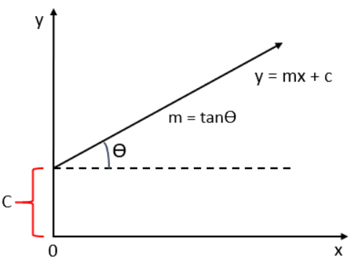
The first step in finding a linear regression equation is to determine if there is a relationship between the two variables. We can do this by using the Correlation coefficient and scatter plot. When a correlation coefficient shows that data is likely to be able to predict future outcomes and a scatter plot of the data appears to form a straight line, we can use simple linear regression to find a predictive function. Let us consider an example.
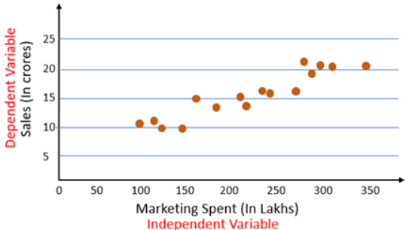
From the scatter plot we can see there is a linear relationship between Sales and marketing spent. The next step is to find a straight line between Sales and Marketing that explain the relationship between them. But there can be multiple lines that can pass through these points.
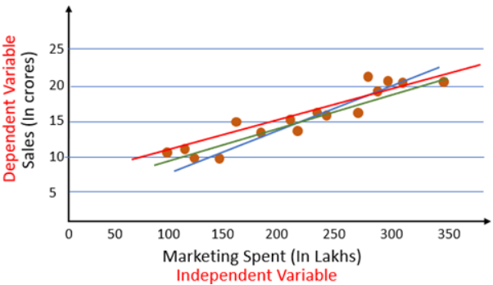
So how do we know which of these lines is the best fit line? That’s the problem that we will solve in this article. For this, we will first look at the cost function.

Cost Function
The cost is the error in our predicted value. We will use the Mean Squared Error function to calculate the cost.
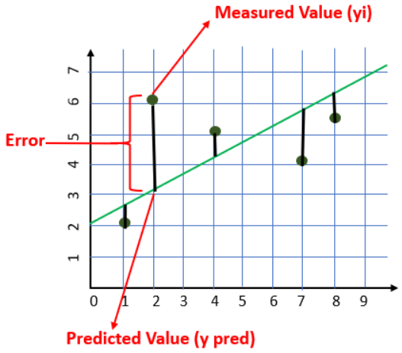
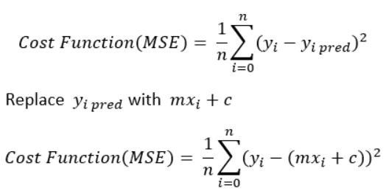
Our goal is to minimize the cost as much as possible in order to find the best fit line. We are not going to try all the permutation and combination of m and c (inefficient way) to find the best-fit line. For that, we will use Gradient Descent Algorithm.
Gradient Descent Algorithm
Gradient Descent is an algorithm that finds the best-fit line for a given training dataset in a smaller number of iterations.
If we plot m and c against MSE, it will acquire a bowl shape (As shown in the diagram below)
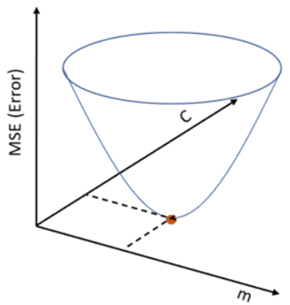
For some combination of m and c, we will get the least Error (MSE). That combination of m and c will give us our best fit line.
The algorithm starts with some value of m and c (usually starts with m=0, c=0). We calculate MSE (cost) at point m=0, c=0. Let say the MSE (cost) at m=0, c=0 is 100. Then we reduce the value of m and c by some amount (Learning Step). We will notice a decrease in MSE (cost). We will continue doing the same until our loss function is a very small value or ideally 0 (which means 0 error or 100% accuracy).

Step by Step Algorithm:
1. Let m = 0 and c = 0. Let L be our learning rate. It could be a small value like 0.01 for good accuracy.
Learning rate gives the rate of speed where the gradient moves during gradient descent. Setting it too high would make your path instable, too low would make convergence slow. Put it to zero means your model isn’t learning anything from the gradients.

2. Calculate the partial derivative of the Cost function with respect to m. Let partial derivative of the Cost function with respect to m be Dm (With little change in m how much Cost function changes).
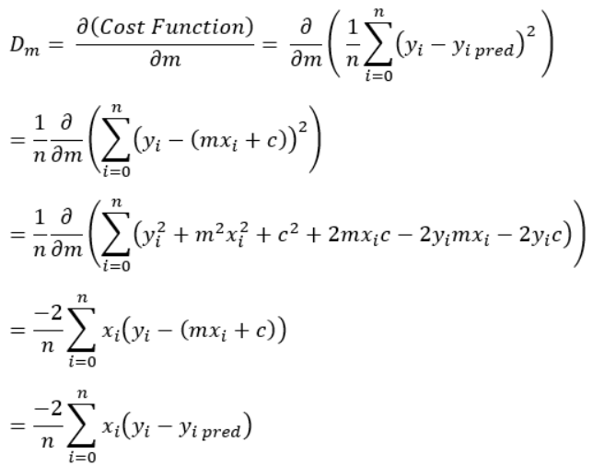
Similarly, let’s find the partial derivative with respect to c. Let partial derivative of the Cost function with respect to c be Dc (With little change in c how much Cost function changes).
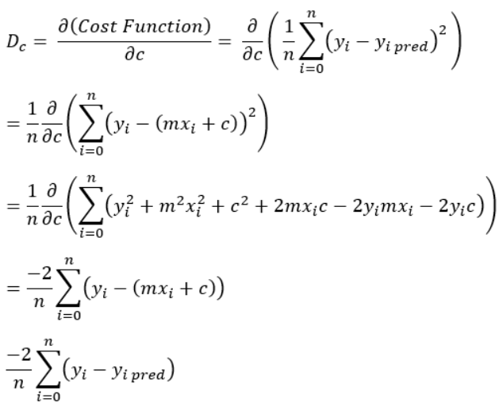

3. Now update the current values of m and c using the following equation:
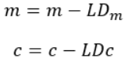

4. We will repeat this process until our Cost function is very small (ideally 0).
Gradient Descent Algorithm gives optimum values of m and c of the linear regression equation. With these values of m and c, we will get the equation of the best-fit line and ready to make predictions.

Types of Gradient Descent
- Batch Gradient Descent: This is a form of gradient descent in which each iteration of gradient descent processes all of the training instances. Batch gradient descent, on the other hand, is computationally highly expensive when the number of training samples is huge. As a result, batch gradient descent is not recommended if the number of training examples is huge. Instead, we prefer to work with stochastic gradient descent or mini-batch gradient descent.
- Stochastic Gradient Descent: This is a kind of gradient descent where each iteration only analyses one training example. As a result, even after one cycle in which just one sample has been evaluated, the parameters are updated. As a result, it’s a lot faster than batch gradient descent. However, if the number of training instances is huge, it will only process one of them, which will add to the system’s overhead because the number of iterations will be high.
- Mini Batch gradient descent: This is a type of gradient descent that is faster than both batch and stochastic gradient descent methods. Here are some examples of bm processing per iteration. Even if there are a huge number of training examples, they are handled in batches of b training examples at a time. As a res ult, it works for larger training instances and with fewer iterations.

For a linear regression model, how do we interpret a Q-Q plot?
A Q-Q (quantile-quantile) plot is a graphical method used to assess the normality assumption of the residuals in a linear regression model. It compares the distribution of the residuals to a theoretical normal distribution.
To interpret a Q-Q plot for a linear regression model, we can follow these steps:
1.First, we fit the linear regression model to the data and obtain the residuals.
2.Next, we create a Q-Q plot of the residuals. The Q-Q plot displays the quantiles of the residuals on the y-axis and the expected quantiles of a normal distribution on the x-axis.
3.If the residuals are normally distributed, the points on the Q-Q plot will fall approximately along a straight line. Deviations from the straight line suggest that the residuals are not normally distributed.
4.If the points on the Q-Q plot deviate from the straight line in the middle or at the tails of the distribution, it may indicate skewness or heavy-tailedness in the residuals.
5.We can also look for outliers on the Q-Q plot. Outliers may appear as points that are far away from the straight line.
A Q-Q plot is a visual tool that can help us assess whether the residuals in a linear regression model are normally distributed. Deviations from the expected straight line in the Q-Q plot may indicate non-normality, skewness, or outliers in the residuals.

What is MAE and MAPE?
MAE (Mean Absolute Error) and MAPE (Mean Absolute Percentage Error) are two common metrics used to evaluate the performance of predictive models, especially in the field of machine learning and data science.
MAE is a measure of the average absolute difference between the predicted and actual values. It is calculated by taking the absolute difference between each predicted value and its corresponding actual value and then taking the average of those absolute differences. The resulting value represents the average magnitude of the errors in the predictions, without regard to their direction.
MAPE, on the other hand, is a measure of the average percentage difference between the predicted and actual values. It is calculated by taking the absolute percentage difference between each predicted value and its corresponding actual value and then taking the average of those absolute percentage differences. The resulting value represents the average percentage error in the predictions, which is useful when the magnitude of the errors relative to the actual values is important.
Both MAE and MAPE are useful metrics for evaluating the accuracy of predictive models, but they have different strengths and weaknesses depending on the specific use case. MAE is a simpler metric and is more robust to outliers, but it does not take into account the relative size of the errors. MAPE, on the other hand, is more sensitive to large errors and is more interpretable in terms of percentage accuracy, but it can be distorted by small actual values and can be difficult to interpret when the actual values are close to zero.

Local & Global Minima Explained with Examples
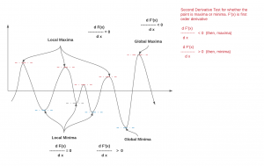
Optimization problems containing many local minima remains a critical problem in a variety of domains, including operations research, informatics, and material design. Efficient global optimization remains a problem of general research interest, with applications to a range of fields including operations design, network analysis, and bioinformatics. Within the fields of chemical physics and material design, efficient global optimization is particularly important for finding low potential energy configurations of isolated groups of atoms (clusters) and periodic systems (crystals). In case of Machine learning (ML) algorithms, theer is a need for optimising (minimising) the cost or loss function. In order to become very good at finding solutions to optimisation problems (relating to minimising functions) including machine learning based problems, one must get a good understanding of the concepts of Local minima / global minima and local maxima / global maxima. In this post, you will learning about local minima and global minima.
Local Minima and Global Minima
The point at which a function takes the minimum value is called global minima. However, when the goal is to minimize the function and solved using optimization algorithms such as gradient descent, it may so happen that function may appear to have a minimum value at different points. Those several points which appear to be minima but are not the point where the function actually takes the minimum value are called local minima. Machine learning algorithms such as gradient descent algorithms may get stuck in local minima during the training of the models. Gradient descent is able to find local minima most of the time and not global minima because the gradient does not point in the direction of the steepest descent. Current techniques to find global minima either require extremely high iteration counts or a large number of random restarts for good performance. Global optimization problems can also be quite difficult when high loss barriers exist between local minima.Take a look at the following picture to understand the concept of local minima and global minima.
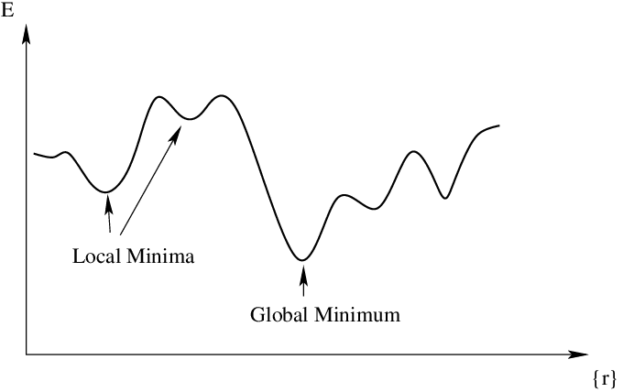
Fig 1. Local Minima vs Global Minima
When you draw the function in 3-dimensional space, this is how the local minima and global minima will look like:
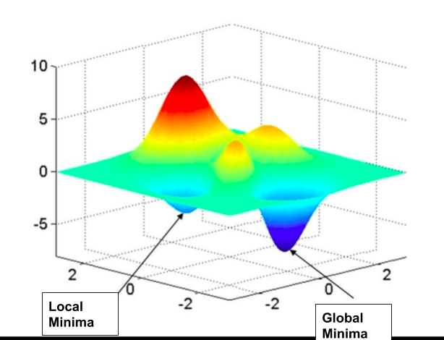
Fig 2. Local Minima and Global Minima in 3-dimensional space
In order to find whether a point is local minima or global minima, one would need to find all possible minima of the function.
Here is an animation that can help you understand the difference between local and global minima in a better manner.
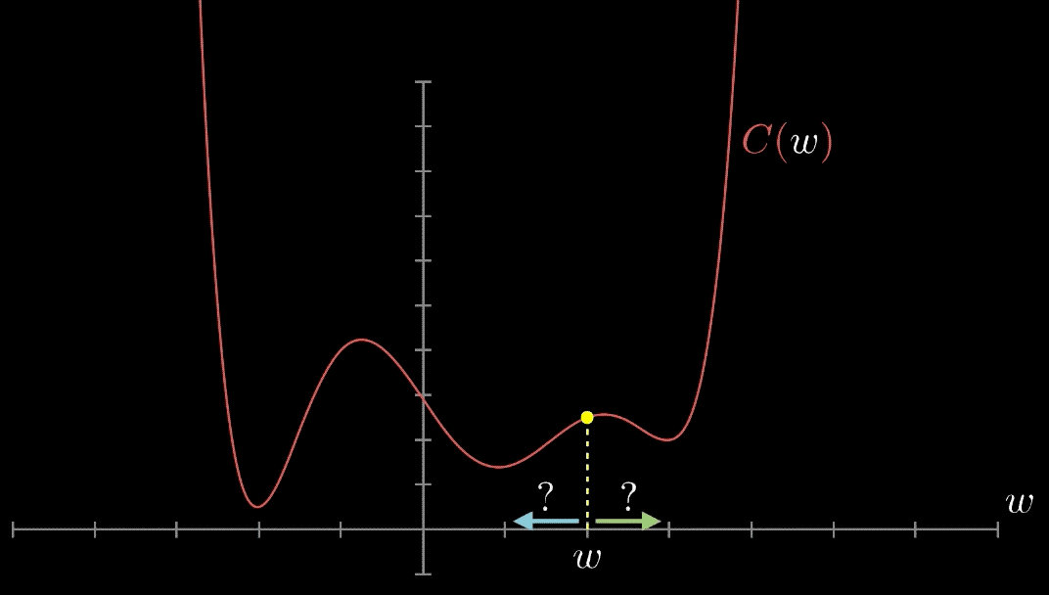
Fig 3. Animation representing local minima and global minima
Pay attention to some of the following in the above animation:
The gradient at different points is found out.
If the gradient value is positive at a point, it will be required to move to left or reduce the weight.
If the gradient value is negative at a point, it will be required to increment the value of weight.
The above two steps are done until the minima is reached.
The minima could either be local minima or the global minima. There are different techniques which can be used to find local vs global minima. These techniques will be discussed in the future posts.
What are some of the techniques for dealing with local minima problems?
The following are some of the techniques which has been traditionally used to deal with local minima problem:

Careful selection of hand-crafted features
Dependence on learning rate schedules
Using different number of steps
How to find minima or maxima of a function?
In order to find the minima or maxima of the function, one needs to determine the first-order derivative of that function and equate the same to zero (0). This can give points where you may end up finding both, one or more minima and one or more maxima. Mathematically, this can be represented as the following. Solve the below function and you would get the value of x where the function is zero.

[latex]\frac{df(x)}{dx} = 0[/latex]

Substitute the value of x in the function and find the value where the function has either minimum values or maximum values. In order to find whether the point is local/global minima or maxima, take the second-order derivative and determine whether the value is positive or negative. If the second-order derivative value is positive, the point is local or global minima and if the second-order derivative value is negative, the point is local or global maxima. The diagram below represents the same.
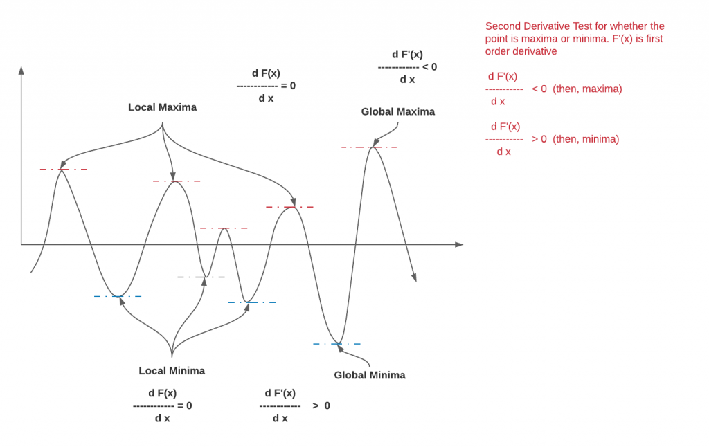

Fig 3. Local Minima / Global Minima and Local Maxima / Global Maxima
You may want to check out my post on gradient descent to understand the importance of finding the minima of the function in the context of machine learning.

Conclusions
Here is the summary of what you learned about local minima and global minima of the function:
A function can have multiple minima and maxima.
The point where function takes the minimum value is called as global minima. Other points will be called as local minima. At all the minima points, the first order derivative will be zero and related value can be found where the local or global minima occurred.
Similarly, the point where function takes the maximum value is called as global maxima. Other points will be called as local maxima.
Local minima and global minima become important for machine learning loss or cost function.

What is multicollinearity and how does it affect linear regression analysis?
Multicollinearity refers to a situation in which two or more independent variables in a linear regression model are highly correlated with each other. This can create problems in the regression analysis, as it can be difficult to determine the individual effects of each independent variable on the dependent variable. When two or more independent variables are highly correlated, it becomes difficult to isolate the effect of each variable on the dependent variable. The regression model may indicate that both variables are significant predictors of the dependent variable, but it can be difficult to determine which variable is actually responsible for the observed effect.

Multicollinearity in linear regression:
- Multicollinearity occurs when two or more independent variables in a linear regression model are highly correlated with each other.
- It makes it difficult to determine the individual effects of each independent variable on the dependent variable.
- It can lead to unstable and unreliable estimates of the regression coefficients and inflated standard errors of the coefficients, affecting the accuracy of the regression results.
- It can also lead to a model that performs poorly in predicting the dependent variable by overemphasizing the importance of the correlated variables and failing to identify other important predictors.
- Multicollinearity can be identified by looking at the correlation matrix of the independent variables and calculating the variance inflation factor (VIF).
- A VIF value greater than 5 or 10 is often considered an indication of high multicollinearity.
- To address multicollinearity, researchers can remove one of the highly correlated independent variables from the model, combine correlated variables into a single composite variable, or use techniques such as ridge regression or principal component analysis to account for multicollinearity in the model.

What are the assumptions of Multiple Linear Regression
For Multiple Linear Regression, all four of the assumptions from Simple Linear Regression apply. In addition to this, below are few more:
- No multicollinearity: There is no high correlation between the independent variables. This indicates that there is little or no correlation between the independent variables. Multicollinearity occurs when two or more independent variables are highly correlated with each other, which can make it difficult to determine the individual effect of each variable on the dependent variable. If there is multicollinearity, then multiple linear regression will not be an accurate model.
- Additivity: The model assumes that the effect of changes in a predictor variable on the response variable is consistent regardless of the values of the other variables. This assumption implies that there is no interaction between variables in their effects on the dependent variable.
- Feature Selection: In multiple linear regression, it is essential to carefully select the independent variables that will be included in the model. Including irrelevant or redundant variables may lead to overfitting and complicate the interpretation of the model.
- Overfitting: Overfitting occurs when the model fits the training data too closely, capturing noise or random fluctuations that do not represent the true underlying relationship between variables. This can lead to poor generalization performance on new, unseen data.

Multicollinearity
- Multicollinearity is a statistical phenomenon that occurs when two or more independent variables in a multiple regression model are highly correlated, making it difficult to assess the individual effects of each variable on the dependent variable.
- Detecting Multicollinearity includes two techniques:
- Correlation Matrix: Examining the correlation matrix among the independent variables is a common way to detect multicollinearity. High correlations (close to 1 or -1) indicate potential multicollinearity.
- VIF (Variance Inflation Factor): VIF is a measure that quantifies how much the variance of an estimated regression coefficient increases if your predictors are correlated. A high VIF (typically above 10) suggests multicollinearity.

Which are different evaluation Metrics for Linear Regression
A variety of evaluation measures can be used to determine the strength of any linear regression model. These assessment metrics often give an indication of how well the model is producing the observed outputs.
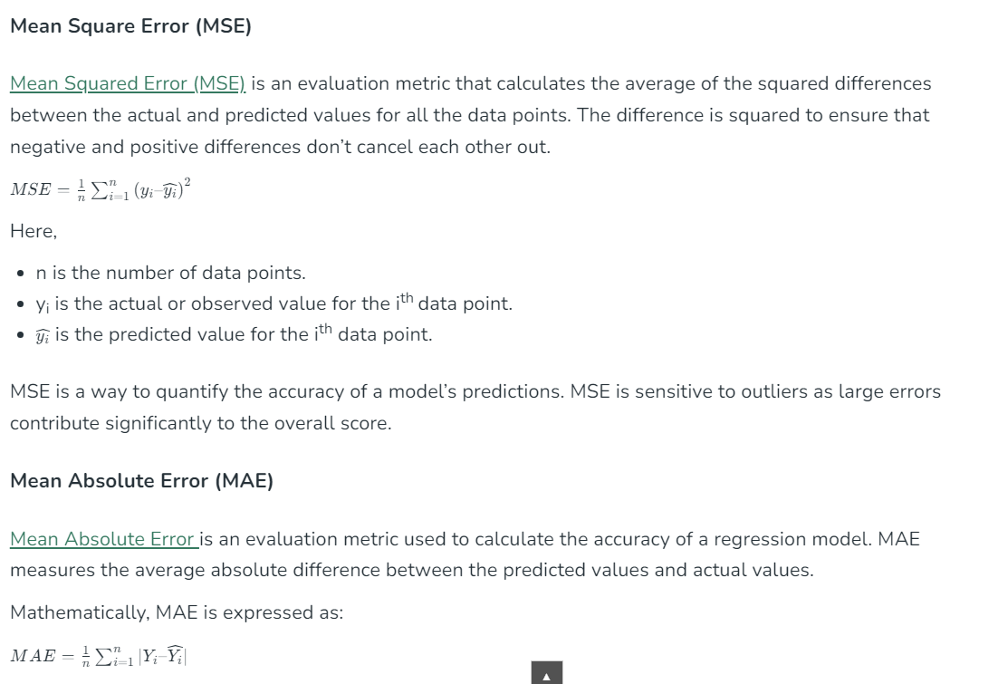
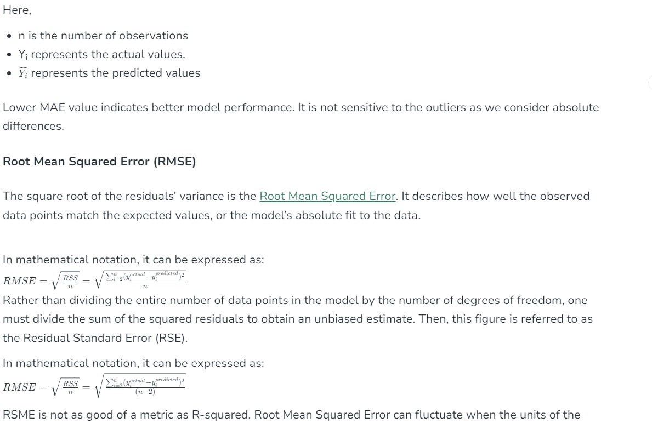
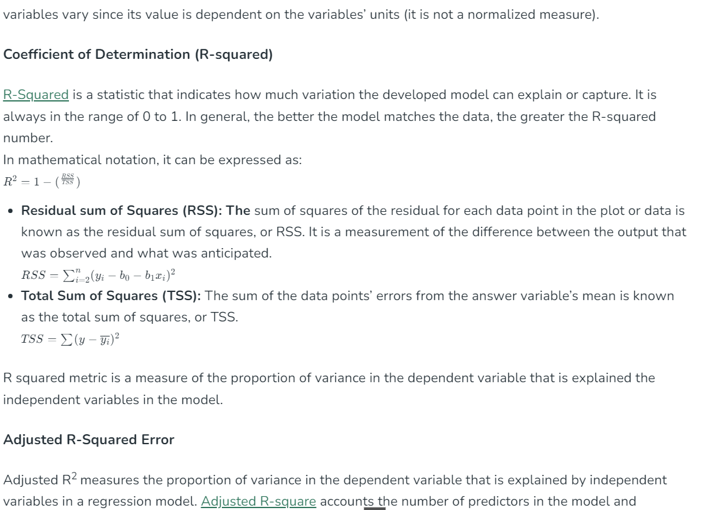
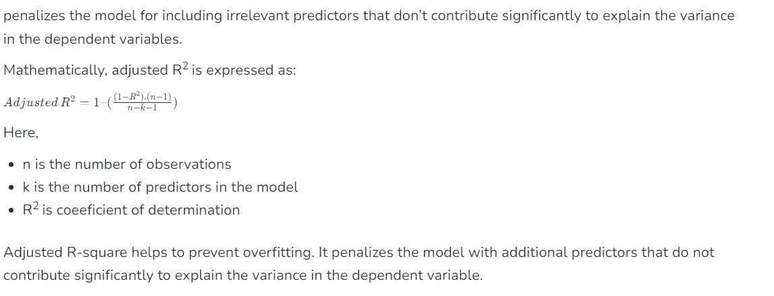

What is Covariance?
Covariance and correlation are fundamental concepts in statistics and mathematics that measure the relationship between two random variables. They are essential tools for understanding how variables change together and are widely used in various fields, including finance, economics, and science.
Covariance:
- It is the relationship between a pair of random variables where change in one variable causes change in another variable.
- It can take any value between – infinity to +infinity, where the negative value represents the negative relationship whereas a positive value represents the positive relationship.
- It is used for the linear relationship between variables.
- It gives the direction of relationship between variables.

Covariance Formula
For Population:
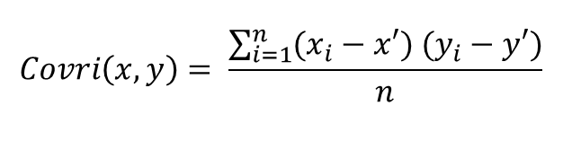
For Sample:
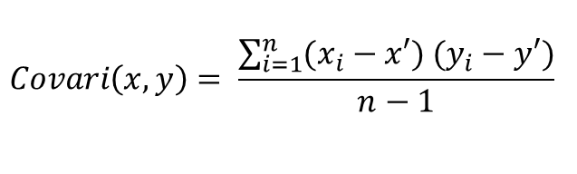
Here, x’ and y’ = mean of given sample set n = total no of sample xi and yi = individual sample of set
Example –
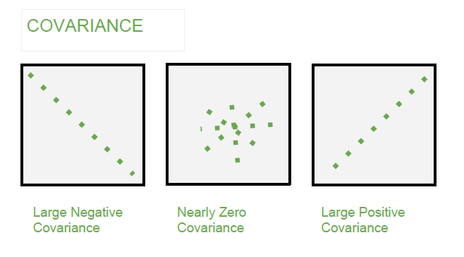

What is Correlation?
Correlation is a standardized measure of the strength and direction of the linear relationship between two variables. It is derived from covariance and ranges between -1 and 1. The correlation coefficient ρ\rhoρ (rho) for variables X and Y is defined as:
- It shows whether and how strongly pairs of variables are related to each other.
- Correlation takes values between -1 to +1, wherein values close to +1 represents strong positive correlation and values close to -1 represents strong negative correlation.
- In this variable are indirectly related to each other.
- It gives the direction and strength of relationship between variables.

Correlation Formula
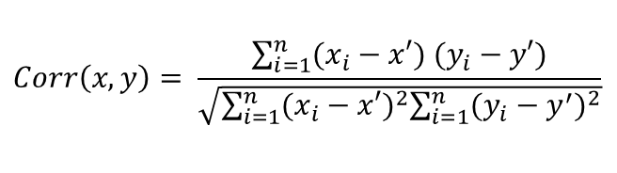
Here, x’ and y’ = mean of given sample set n = total no of sample xi and yi = individual sample of set
Example –
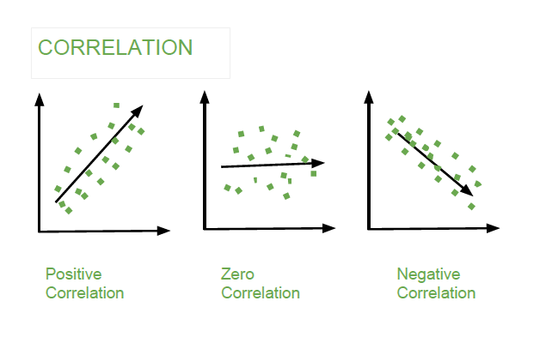

Covariance versus Correlation
Table showing difference between Covariance and Covariance:
Covariance | Correlation
Covariance is a measure of how much two random variables vary together | Correlation is a statistical measure that indicates how strongly two variables are related.
Involves the relationship between two variables or data sets | Involves the relationship between multiple variables as well
Lie between -infinity and +infinity | Lie between -1 and +1
Measure of correlation | Scaled version of covariance
Provides direction of relationship | Provides direction and strength of relationship
Dependent on scale of variable | Independent on scale of variable
Have dimensions | Dimensionless

Applications in Engineering
In engineering, covariance and correlation are crucial for:
- Risk Management: Assessing the relationship between different factors affecting a system’s performance.
- Signal Processing: Analysing the correlation between signals to extract useful information.
- Quality Control: Monitoring the relationship between process variables to ensure consistent product quality.

What is Standard Deviation?

Definition
Standard Deviation measures how far a group of numbers is from the mean. It is useful to compare the spread of two separate datasets with approximately the same mean.
- Standard Deviation is the square root of Variance.
- Standard Deviation is very sensitive to extreme values.
- If two datasets have the same mean but different standard deviations, then one with the higher SD will be more spread out from the center.
- If all the values in the dataset are equal, then the SD is zero.
- A lower standard Deviation indicates data points in the dataset are dense near the mean.
Also Read: All about Symmetric Matrix

Formula of Standard Deviation
Population
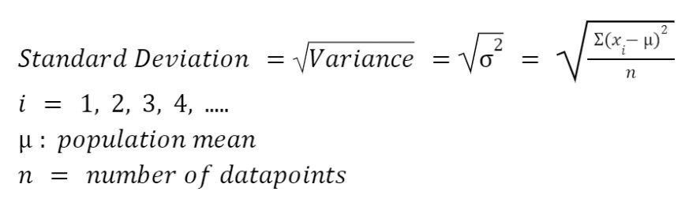
Sample
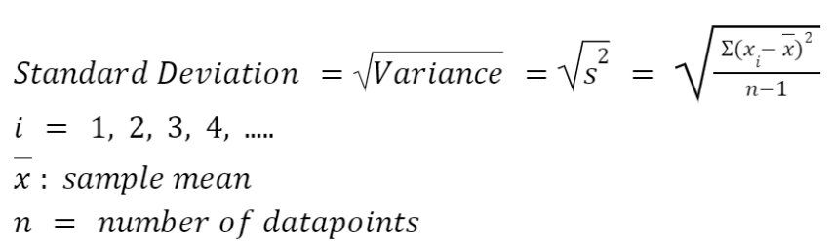

Example
Example: Let there be two cricket players: Pant and Kartik, and you have to select one for the cricket world cup. The score of both the players in the last five T-20 matches are as follows:
Kartik | Pant
23 | 34
28 | 85
45 | 02
59 | 15
63 | 77
Answer: Now, we will find the SD, and one who has the lesser value of SD will be more consistent.

Case -1: Kartik
Runs (xi) | Squared Deviation (xi– mean)2
23 | (23 – 43.6)2
28 | (28 – 43.6) 2
45 | (45 – 43.6) 2
59 | (59 – 43.6) 2
63 | (63 – 43.6) 2
Mean = (23 + 38 + 45 + 59 + 63) / 5 = 43.6 | Sum of Squared Deviation = 1283.2
Hence, Variance = s 2 = (sum of standard deviations) / n – 1 = 1283.2 / 5-1 = 1283.2/4 = 320.8
Hence, Standard Deviation = s = sqrt(variance) = sqrt (320.8) = 17.91
Now, similarly we will find the standard deviation of runs for Pant
Case 2: Pant
Runs (xi) | Squared Deviation (xi– mean)2
34 | (34 – 42.6) 2
85 | (85 – 42.6) 2
02 | (2 – 42.6) 2
15 | (15 – 42.6) 2
77 | (77 – 42.6) 2
Mean = 42.6 | Sum of Squared Deviation = 5465.2
Hence, s2 = (sum of standard deviations) / n – 1 = 5465.2 / 5-1 = 5465.2/4 = 1366.3
Hence, s = sqrt(variance) = sqrt (1366.3) = 36.96
From above, the standard deviation of Kartik score is less than the pant, so Kartik is more consistent than Pant in scoring runs.

Application
- Machine Learning: Used in Hypothesis Testing and Confidence Interval
- Finance: Used to understand how risky and volatile the investment is, stability of mutual funds
- Forecasting: To make the weather forecast, projections about the company’s revenue
- Sports: Used to select the players in the team (As discussed in the above example.)

Key differences and similarities
- Variance measures the dispersion of the dataset, while Standard Deviation measures the spread of the data around the mean.
- Variance is the average squared difference from the mean, while standard Deviation is the square root of the Variance.
- Standard Deviation is expressed in the same unit as the values in the dataset, while the Variance is expressed in a square unit.
- Both Standard Deviation and Variance are always positive.
- If all the values in the dataset are equal, then both Variance and standard Deviation are zero.

